Screw Size and Placement
Using the proper screw for the proper job is extremely important. The most commonly used screws are the Hex Head #8 & #10 (both ¾”). This is the guideline for using both self-drilling and zip screws with different gauges of metal. The screws are not to EXCEED the “Max. Total Thickness” as specified below.

Gauge | Inches (Decimal) | 2 Layers
18 | 0.050 | 0.100
20 | 0.038 | 0.075
22 | 0.031 | 0.063
24 | 0.025 | 0.050
26 | 0.019 | 0.038
28 | 0.016 | 0.031
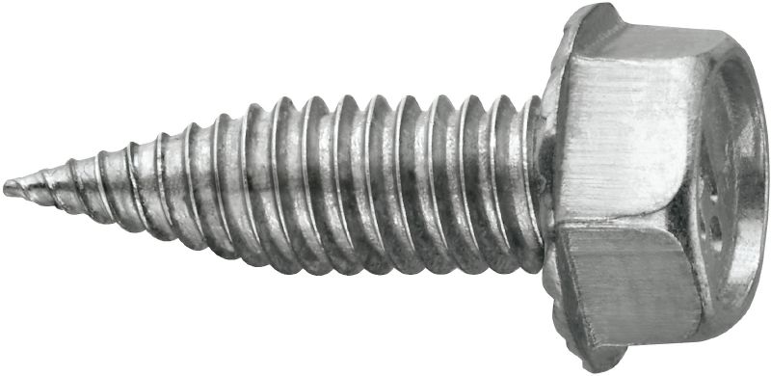
HWH Zip Screws | Gauge Range | Max. Total Thickness
#8 x ¾” | 22-28 | 0.072
#10 x ¾” | 20-28 | 0.072
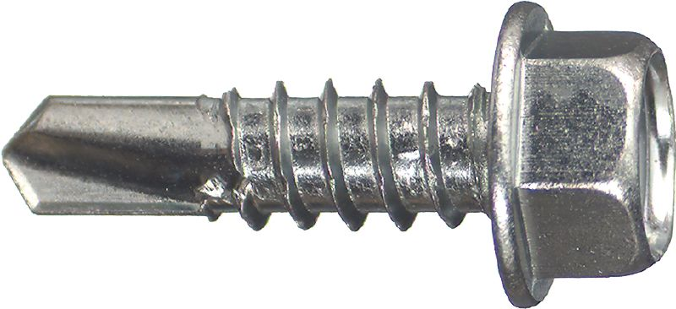
HWH Self-Drilling | Gauge Range | Max. Total Thickness
#8 x ¾” | 16-22 | 0.100
#10 x ¾” | 14-20 | 0.175

Placement of screws is equally important as choosing the right screw for the job. As a general rule of thumb, screws are not to be placed more than 6-8” apart on TDF or ductmate frames.

For round pipe, screws must be used in uniform intervals of at least 15” along the circumference. Three screws minimum on 14” or less diameter.

When conditions permit, always screw from the lighter gauge metal into the heavier gauge metal.

Although the cost of screws can accumulate over time, the cost of failing duct or equipment can be much more costly. Any job specifications supercede these guidelines. As with any fasteners, when in doubt use a more heavy duty screw or refer to your foreman/project manager.

